Design Document

Introduction:
This project introduces a comprehensive fitness and wellness tracking application designed to meet the growing need for simple, meaningful, and user centered health management. Many individuals struggle to maintain consistent routines because their health information is scattered across multiple apps, each focusing on only one part of their lifestyle. This application brings everything together by integrating physical activity tracking, nutrition monitoring, and wellness insights into a single, accessible platform. The goal is to give users a clear understanding of how their daily choices influence their long term well-being and to help them make informed decisions through organized, data driven feedback. By presenting information in a way that is easy to understand and personally relevant, the app aims to reduce confusion, increase awareness, and support healthier habits.
Beyond tracking numbers, this project focuses on motivation, accountability, and long term engagement. Many people begin their health journey with excitement but lose momentum when progress becomes difficult to see or understand. This application addresses that challenge by offering personalized recommendations, visual progress indicators, and meaningful insights that encourage users to stay committed. Our team plans to make tracking your health successful by creating an experience that feels supportive, intuitive, and genuinely helpful. By combining fitness, nutrition, and wellness into one cohesive system, the project aims to provide a tool that not only records data but actively guides users toward a healthier and more balanced lifestyle. Below are examples of a Fitness & Wellness Tracker:

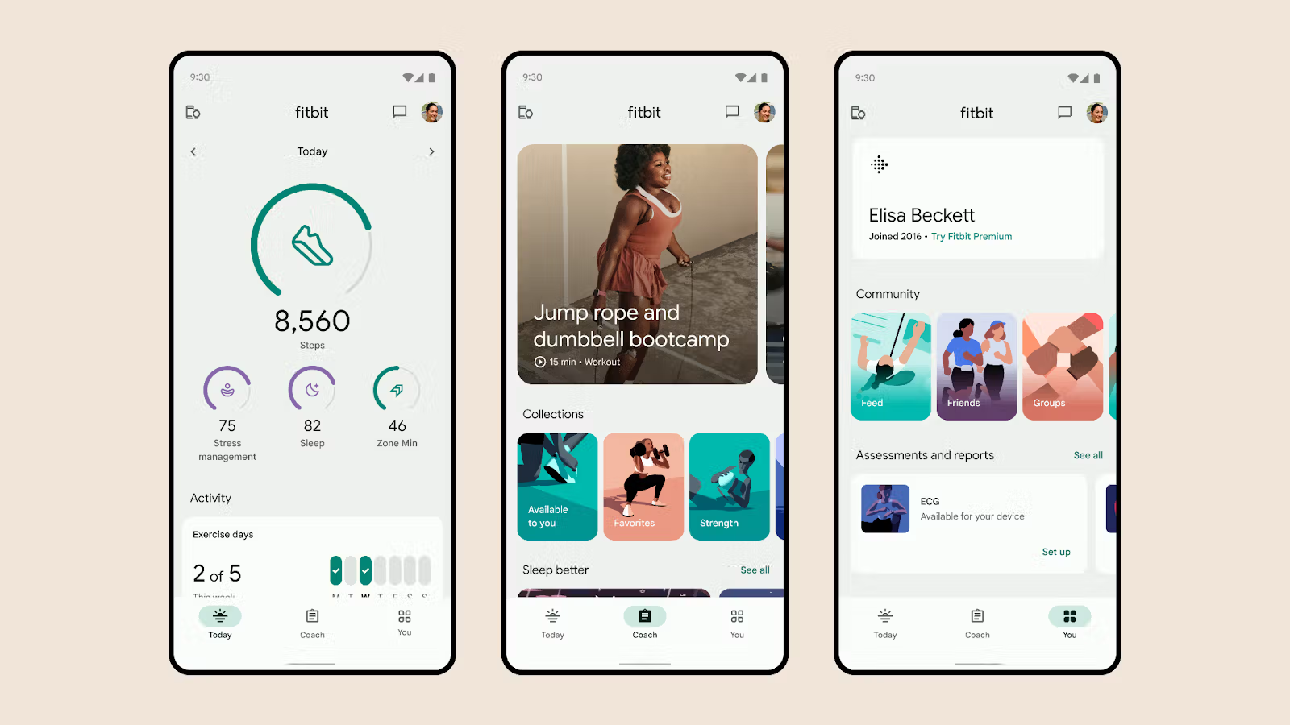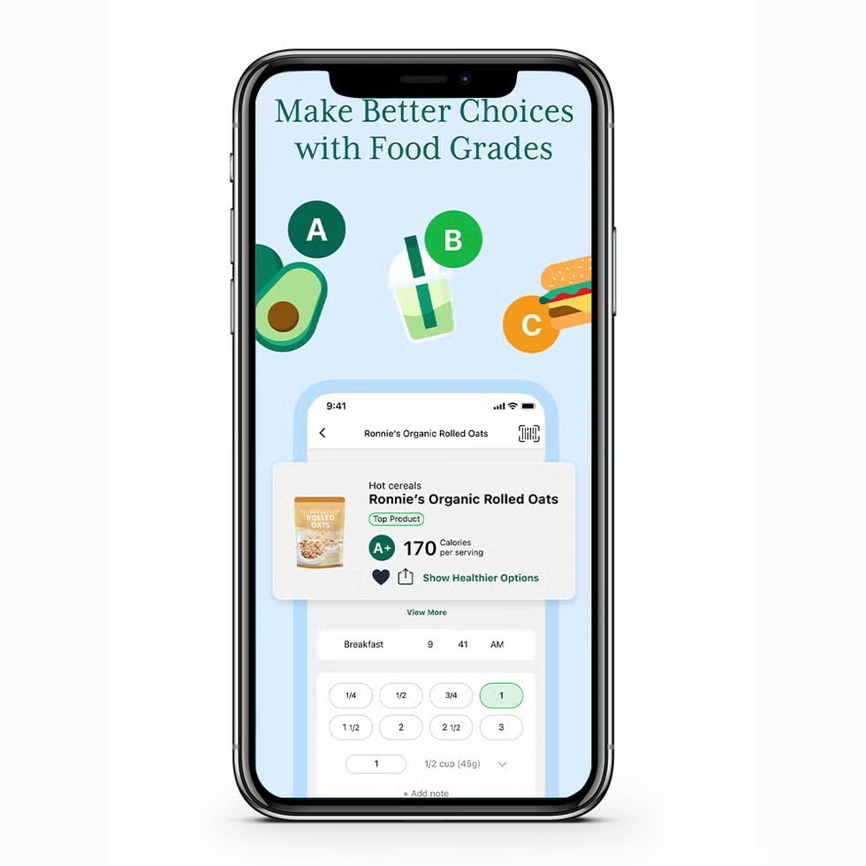

System Architecture:
The Fitness and Wellness Tracker are developed in a modular, layered structure, which facilitates greater clarity, ease of maintenance, and scalability. Due to the involvement of numerous programmers, all working on different parts of the system, the architecture of the system has been designed to avoid any cross-over or overlap. This helps the user interface, data management, and logic of the system to exist in an isolated form, thus creating room for future developments. For example, if the system is intended to incorporate some other devices as well, it can be achieved without going through a process of re-engineering the entire system.
At the heart of this application is a programming paradigm known as Model View Controller, or MVC for short. The MVC framework is commonly used for mobile and web application development due to its layering structure, which consists of three separate sections: the Model, the View, and the Controller, meaning that a student development team will be able to divide these responsibilities and create a well-designed application that is easy to debug.

Work Breakdown Structure (WBS):

The Work Breakdown Structure divides the project into major phases and tasks. This structure helps the team stay organized and ensures that all necessary work is accounted for.
Phase 1: Planning
- Define project goals
- Identify core features
- Assign team roles
- Gather initial requirements
- Create early sketches and concepts
Phase 2: Design
- Develop UI wireframes
- Create navigation flow diagrams
- Draft database schema (TBD)
- Review design with team
- Make revisions based on feedback
Phase 3: Development
- Implement user authentication
- Build activity tracking module
- Add nutrition logging functionality
- Develop wellness insights system
- Integrate database
- Conduct internal testing
Phase 4: Testing
- Perform unit testing
- Identify and fix bugs
- Conduct user acceptance testing
- Test performance on multiple devices
Phase 5: Deployment
- Prepare final build
- Review documentation
- Assemble submission package

Mockup:

Case Diagram:

Fitness & Wellness App

Log Workout
Log Meals

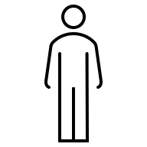
User
View Daily Summary

Receive Wellness insights
Track Progress

Tools and Technologies:

The project will utilize a combination of development, design, and collaboration tools to support efficient workflow and communication.

Development Tools
- Visual Studio Code or Android Studio
- GitHub for version control
- Firebase or SQLite for database management
Design Tools
- Figma or Canva for UI/UX design
- Shared cloud folders for storing design assets
Collaboration Tools
- Microsoft Teams or Google Chat for communication
- Shared documents for planning and documentation
Testing Tools
- Built‑in debugging tools
- Mobile device emulators
- Physical devices for final testing (if available)

Detailed User Case Descriptions:

Activity Diagram for Core User Flows:

Sequence Diagram for System Interactions:

Comprehensive Test Case Suite:

Final UI Mockups and Screen Designs:

Project Schedule and Gantt Chart:

System Evolution and Future Enhancements:

Final Summary and Conclusion:

Project Draft Design Images:

